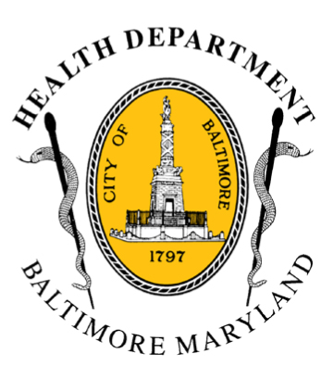
BCHD PRESS RELEASE
Baltimore City Health Department
1001 E. Fayette Street • Baltimore, Maryland 21202
Stephanie Rawlings-Blake, Mayor
Leana Wen, M.D., Commissioner of Health

FOR IMMEDIATE RELEASE
Media Contact: Michael Schwartzberg, PIO
O: (443) 984-2623 C: (443) 462-7939 E: michael.schwartzberg@baltimorecity.gov

Baltimore City Prepares For 2015 Code Red Heat Alert Season

Officials Caution Although 2014 Season Was Mild,
Residents Need To Prepare For Hot Weather

BALTIMORE, MD (May 21, 2015) – Today, Baltimore City Health Commissioner Dr. Leana Wen was joined by representatives of the Mayor’s Office, Baltimore City Fire Department, Office of Emergency Management, and Office of Human Services / Community Action Partnership in announcing the kickoff of Code Red Heat Alert season, which began May 15th and runs until September 15th. Tomorrow, May 22nd, is National Heat Awareness Day as recognized by the National Weather Service.

A Code Red Heat Alert will be issued by the Health Commissioner when the forecasted heat index is equal to or greater than 105˚F. The heat index measures air temperature and relative humidity to indicate how hot it feels to an individual outside.

“Heat is one of the leading weather-related killers in the United States, resulting in hundreds of people dying and thousands becoming ill every year,” said Dr. Wen. “Heat waves are silent killers and a public health threat, particularly for the young, the elderly and those in our city who are the most vulnerable.”

“Having a unified and coordinated agency response to potentially dangerous temperatures gives us the ability to best protect the residents of, and visitors to, Baltimore and to save lives,” said Mayor Stephanie Rawlings-Blake.

When a Code Red Heat Alert is declared, city agencies will coordinate the opening of cooling centers to offer air-conditioned space and water for residents without access to cool air in their homes. Cooling centers will generally be open at five Community Action Partnership Center locations from 9 a.m. to 7:00 p.m. on weekdays and 11 a.m. to 7:00 p.m. on weekends, and at six senior centers from 9 a.m. to 7:00 p.m. on weekdays. A list of these centers is available on the Health Department website at http://health.baltimorecity.gov/emergency-preparedness-response/code-red.

“When the heat index is predicted to be dangerously high, all Community Action Partnership Centers will serve as cooling centers with air conditioned space and provide cold bottled water to the public,” said Lori Cunningham, Director of the Community Action Partnership Center. “The Community Action Partnership Centers are a safe haven for everyone to escape the expected high temperatures and will hopefully eliminate severe dehydration, heat cramps, heat exhaustion and heatstroke related incidents.”

-more-

2-2-2

During periods of extreme heat, the Baltimore City Health Department recommends that city residents:

- Drink plenty of water and avoid alcohol and caffeine
- Reduce outside activities and stay inside in air-conditioned locations
- Never leave children or pets alone in closed vehicles, even for short periods of time
- Check on older, sick, or frail neighbors who may need help responding to the heat
- Watch out for signs of heat exhaustion and heat stroke, which include:
- Confusion
- Hot, dry, flushed skin or cool and clammy skin
- Lighheadedness
- Nausea
- Call 911 immediately if any of these symptoms occur

Baltimore City Code Red Statistics 2012 - 2014

Year | # Code Red Days | # Hyperthermia-Related Deaths
2014 | 1 | 3
2013 | 6 | 2
2012 | 17 | 13

Information on declared Code Red days will be shared on the Health Department website, health.baltimorecity.gov; Health Department social media (Twitter - @Bmore_Healthy and Facebook - www.facebook.com/BaltimoreHealth, the Baltimore City 311 line and with local news media.

###

